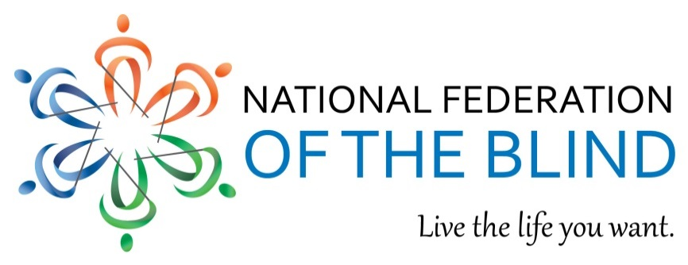

Legislative Agenda of Blind Americans

Priorities for the 114th Congress, SECOND Session
The National Federation of the Blind (NFB) is the oldest and largest nationwide organization of
blind people. We represent the collective views of the 1.3 million blind Americans. All of our leaders and the vast majority of our members are blind, but anyone can participate in our movement.

- The Transitioning to Integrated and Meaningful Employment Act (HR 188, S 2001)
Section 14(c) of the Fair Labor Standards Act allows employers to pay workers with disabilities subminimum wage because of the false assumption that they are less productive than nondisabled workers. This antiquated provision breeds low expectations and discourages disabled Americans from reaching their full vocational potential. HR 188 and S 2001 will responsibly phase out the use of Section 14(c) Special Wage Certificates, ending the era of segregated, subminimum wage work.
- The Accessible Instructional Materials in Higher Education (AIM HE) Act
Electronic instructional materials have replaced traditional methods of learning in postsecondary education, but the overwhelming majority of ebooks, courseware, web content, and other technologies are inaccessible to students with print disabilities. The law requires equal access in the classroom but fails to provide direction to schools for the way it applies to technology. AIM HE creates voluntary accessibility guidelines for educational technology to improve blind students’ access to course material, stimulate the market, and reduce litigation for schools.
- Equal Access to Air Travel for Service-Disabled Veterans (HR 2264)
The Space Available Program allows active-duty military, Red Cross employees, and retired members of the armed services to travel on military aircraft if space is available. HR 2264 reverses the exclusion of 100 percent service-disabled veterans who were discharged before September 23, 1996, and entitles them to the program’s privileges even though they were never classified as “retired.”
- The Marrakesh Treaty to Facilitate Access to Published Works for Persons Who Are Blind, Visually Impaired, or Otherwise Print Disabled
Despite the ability to convert print books into accessible formats like Braille, large print, audio, and digital copies, millions of blind and otherwise print-disabled Americans are excluded from accessing 95 percent of published works. The Marrakesh Treaty calls for contracting parties to provide in their national copyright laws for a limitation or exception that allows for the reproduction, distribution, and cross-border exchange of accessible works.
Mark Riccobono, President | 200 East Wells Street at Jernigan Place Baltimore, MD 21230 | 410 659 9314 | www.nfb.org
The National Federation of the Blind knows that blindness is not the characteristic that defines you or your future. Every day, we raise the expectations of blind people because low expectations create obstacles between blind people and our dreams. You can live the life you want; blindness is not what holds you back. These priorities will remove obstacles to employment, education, travel, and access to published works. We urge Congress to support our legislative initiatives.

